2022 Pierce County Fair
Photography Contest
Show us your Best Shot!

We know you have some amazing pics to share! Print them and show them off!
Entries Accepted:
July 6th 4-7 pm
July 7th 8-10 am
Judging:
July 7th 2-4 pm

$50 cash prize to Best in Show

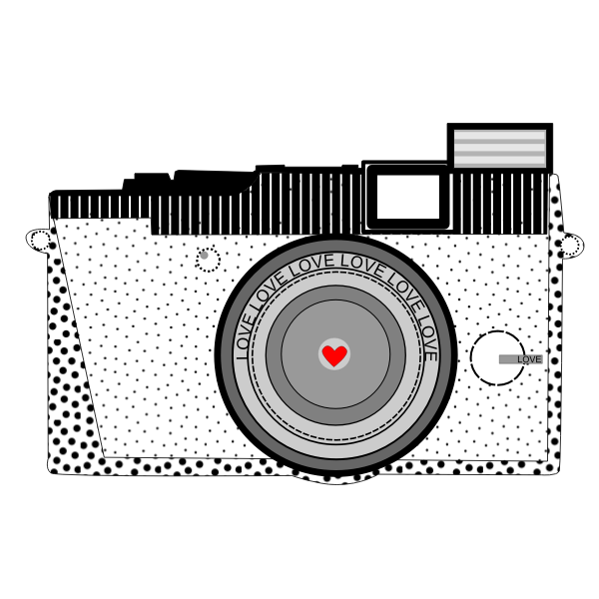
Competition Categories Include:
Lot 1: Scenery
Lot 2: People
Lot 3: Animals
Lot 4: Black and White
Lot 5: Weather

Because Life is Beautiful!

More Open Class information can be found at:
http://www.piercecountyfairrugby.com

